Homepage: https://getargeting-2026.vercel.app/

- Just a reminder that the cookies bar that pops up at the bottom of the website when you first navigate to the site does not have an “accept” button right now.

- Do we want to make this NIH funding statement stand out more?:

- Can you put a glove on the hand holding the mouse? We would never hold a mouse with an un-gloved hand:
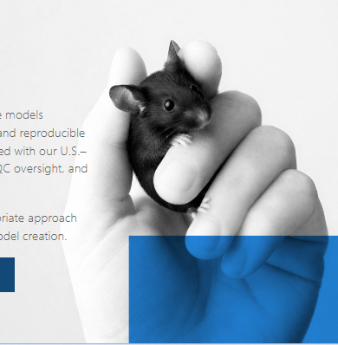

- I don’t think this “request a quote” button works (this is on the quote request page when you click to it):
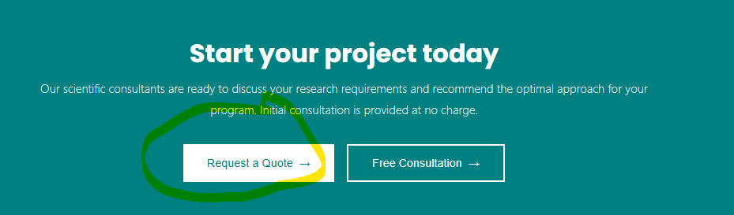

- We need to change this to within 1 business day and remove the rest of the text. (this is on the quote request page when you click through):
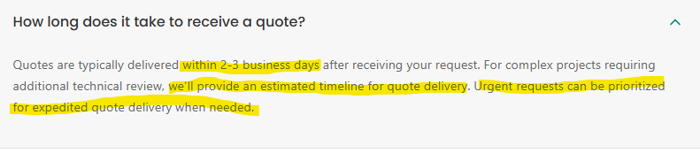

- Can you set a rule across the entire site to turn any “ITL” into “ingenious targeting laboratory”:
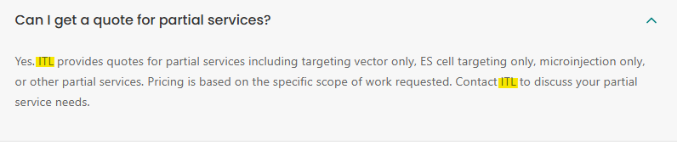

- (Back to Homepage): For this box, can you either put “in vivo” on the same line, or italicize it? It reads weird split up like this:
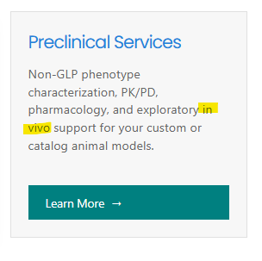
- Can you change this from 30 years to 25 years:
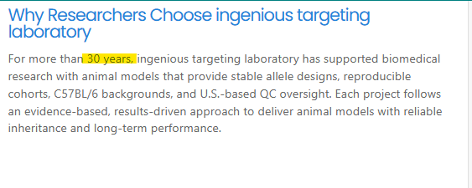
- Can you put bullet points before each service item, and can you add a period at the end of the last service item:
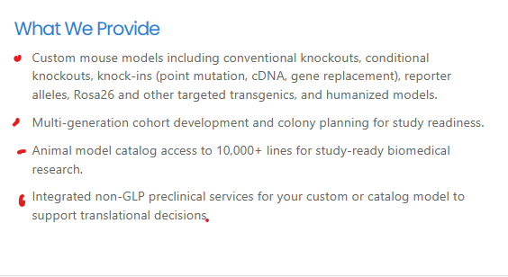

- The below button doesn’t work, and we may want to just remove it completely because odds are we won’t address timeline specifically:
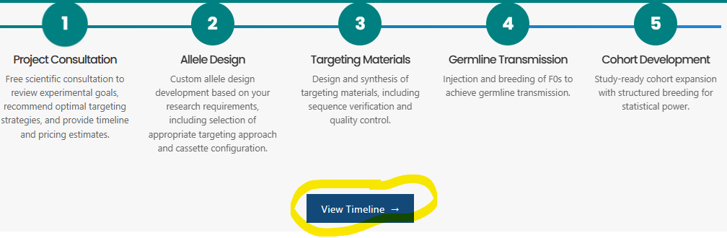

- This would have to be vetted by one of our breeding scientists to confirm if it’s accurate. Until then we shouldn’t go live with this on the site:
